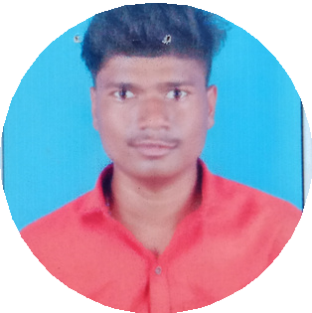PRAVEEN TELI

J A V A F U L L S T A C K D E V E L O P E R

# Contact About Me

### Phone



**7666207839 Seeking a challenging role at an established organization to start my career in Java full**

**stack developer.**

### Email

[**telipraveen393@gmail.com**](mailto:telipraveen393@gmail.com)

### Address

**Rajajinagr, Prakash Nagar Banglore. 560010**

# Expertise

**Hardworking Problem**

**solving process fallow Learn new**

**leadership**

# Education

## 2015

*Maharashtra State Board*

**S S L C 77.60%**

## 2017

*Maharashtra State Board*

P U C/H S C 60.77%

## 2020

*Punyshloka Ahiliyadevi*

**Shree Allam Prabhu High school Halli**

**M V High school and Jr. college Umadi**

Sangola College Sangola

**Do better**

# Language

Kannada English Hindi

**Marathi**

# Skills

*Holkar Solapur University Solapur*

BSC (C.S) 67.34%

## 2022

*Punyshloka Ahiliyadevi Holkar Solapur University Solapur*

MSC (C.S) 64.08%

# Project

Sangola College Sangola

•Core Java

•JDBC

•Hibernate

•Oracle MySQL

•Html and CSS

•Javascript

**Face Mask Detective June/2022**

The main objective of the face detection model is to detect the face of individuals and conclude whether they are wearing masks or not at that particular moment when they are captured in the image.

Praveen Teli